Geometry: Unit 11, Lesson 7
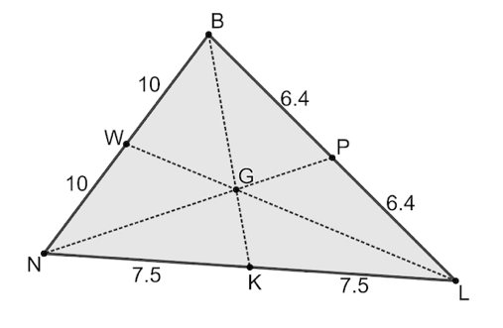
- Triangle $NBL$ is shown, with point $W$ on $\overline{NB}$, point $P$ on $\overline{BL}$, and point $K$ on $\overline{NL}$. Point $G$ lies inside the triangle. $WB=10$, $BP=6.4$, $PL=6.4$, $KL=7.5$, $NK=7.5$, and $WN=10$. What are the midpoints of the sides of $∆NBL$?

$W$, $P$, and $K$

- The point that divides a segment into two congruent parts is called what?

The midpoint

- Constructing a perpendicular bisector can be used to find what?

Midpoint of a segment

